The start of the double bind test is approaching rapidly. There is a great deal of pressure on you to begin building the actual database. Before you can do that, though, you must perform a final review to make sure the database is normalized and complete.

•
To-Do (1). Review all the requirements and business rules.
- Doctor and patients should not enabled with access to the information about the drug.
- One two main supervisors should able to access each and every information about trail.
- Each doctor should enable with information about 20 patients assigned to them.
- One of the supervisor is a pharmacist. He should supply the drug twice a month according to the checkup and interview data. So they should about to track the appointment details too.
- Database should be designed in a way that researches can track patient information from their first screening through each of their visits.
- After each interview, the response of the treatment should be recorded individually. The researches should able to access the patient depression condition,physical side effects, BP, and any problems that are faced by patient during the time of trail.
- Doctor should enable with facility to enter the data like blood presser, test results, depression indication and their own note.
- Patient should only able to see their own medical profile, doctor’s notes and nothing more then that.
- Whole database should be secured from outside intruders.

•

To-Do(2) Define your entities and attributes and the relations that exist between them.

Entities | Attributes | Relationship
Patient | Patient_Key  Patient_ID  Patient_First_Name  Patient_Last_Name  Patient_DOB  Patient_Medical_History | One to One
Supervisor | Supervisor_Key  Supervisor_ID  Supervisor_First_Name  Supervisor_Last_Name | One to One
Doctor | Doctor_Key  Doctor_ID  Doctor_First_Name  Doctor_Last_Name | One to One
Drug_Type | Drug_Key  Drug_Prozac  Drug_New | One to Many
Visit | Visit_No  Visit_Date  Visit_Time | One to Many
Security | Patient_Password  Patient_Password_Hint  Supervisor_Password  Supervisor_Password_Hint  Doctor_Password  Doctor_Password_Hint | One to One
Depression | Depression_Type  Depression_Duration | One to One

Create a logical model using crow’s feet notation in Visio or hand draw it on graph paper if you prefer. •
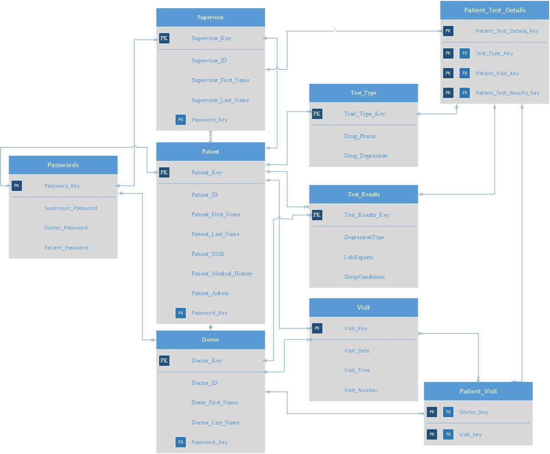
•

Identify the key fields for each Entity and the foreign keys.

•

Analyze the diagram. Identify which role (domain, linking, lookup, weak) each entity plays in your database.

